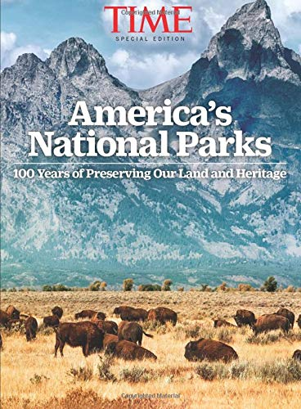
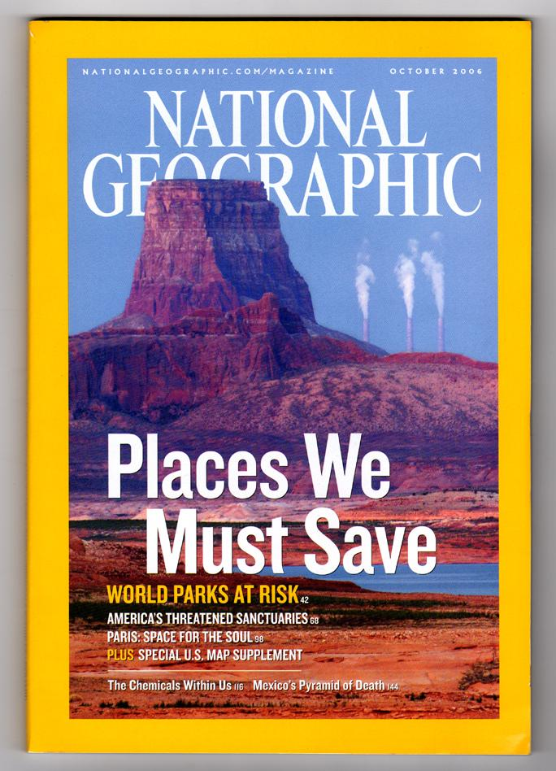
Geology of National Parks Journal Articles Assignment

Our library has access to the journals Time, National Geographic and National Parks: The magazine of the National Parks Conservation Association
We will explore publications relating to issues concerning the National Park system: This activity involves reading, writing, and discussing scientific literature. Articles are posted on the Canvas and are accessible via the library journal source.
YOUR TASK: Choose two articles from the list below:
- One from the Parks Group AND one from the Environmental Group.
Read then write a brief summary of both articles. This will be handed in.
Be prepared to discuss the articles in class in small groups.
Parks article Group: Choose one:
1.Celebrating Americas Crown Jewels – Time Magazine Special National Parks issue
OR 2. This is your Land – Time Magazine Special National Parks issue
Environmental article Group: Choose one:
- This is your Brain on Nature – National Geographic January, 2016
OR 2. Plastic – National Geographic June, 2018.
SECOND NATIONAL PARKS LITERATURE ASSIGNMENT:
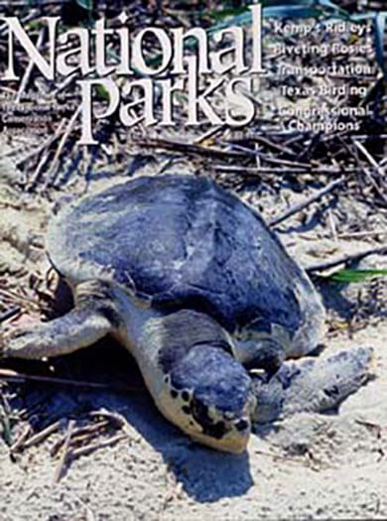
YOUR TASK: Using the National Parks journal: choose one article/item from any recent issue (last several years is fine), download, read and write a summary. Be prepared to present this topic and discuss briefly in class. Include why this article and its topic interested you.

